

Submitted by:
Name: Istiak Alam
ID: 05
Batch: 20
Lab report: 03
Date: 16.10.22
Course: CSE LAB
Course Code: 1202
Assignment Topic: Structured Programming Problems Solve & description

Submitted to:
Nafisa Tabassum

LECTURER, NDUB

Problem No. 01
Name of the problem:
Write a C program to find the maximum in the given two numbers using the conditional operator
Introduction
Implementing program in C is very interesting. To implement the problem given above we should remember the procedure to display outcome. That is, we should consider about the required inputs, the particular process that will be applied upon the input data and the output whether it is desired or not. The given problem gives me an opportunity to have an exercise on the procedure.

Program:
//find the maximum number among two numbers
#include <stdio.h>
int main()
{
int x,y;
printf("Enter your first number:");
scanf("%d",&x);
printf("Enter your second number:");
scanf("%d",&y);

(x>y) ? printf("The largest number is:%d",x) : printf("The largest number is:%d",x);
return 0;
}

Output:
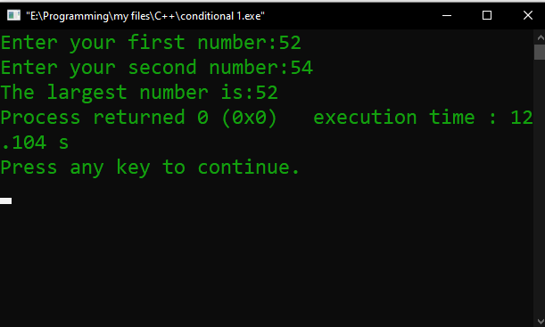
Figure 1 Output

Description:
Begin with // indicating that this one line is a comment, “//find the maximum number among two numbers”. I insert comments to document programs and improve program readability. My Comments do not cause the computer to perform any action when the program is run. In the 1st line I used a comment for indicate the purpose of this code. In line 2 I used a library function called #include which is a directive to the C preprocessor. In the 4th line the main function begins execute the program. In the main function int main () all the function were written enter in the curly brace {}.
The names x and y are the names of variables. In this program first of all I used int x, y; This means that it needs to be worked on those variables. Then I used printf for user prompt, “Enter the first number”. Our next program uses the Standard Library function scanf to obtain two integers typed by a user at the keyboard, computes the compare of these values by using conditional operator and prints the result using printf for showing “The largest number” in the monitor.
The output is also here, as we can see the output in fig 1 In line 13 I indicate that the program ended successfully by using return 0;
Problem No. 02
Name of the problem:
Write a C program to find the inputted number is positive or negative using the conditional operator.
Introduction
Implementing program in C is very interesting. To implement the problem given above we should remember the procedure to display outcome. That is, we should consider about the required inputs, the particular process that will be applied upon the input data and the output whether it is desired or not. The given problem gives me an opportunity to have an exercise on the procedure.

Program:
//Find the inputted number is positive or negative
#include <stdio.h>

int main()
{
int x;
printf("Enter your first number:");
scanf("%d",&x);

(x>0) ? printf("The number is positive +%d",x) : printf("The number is negative %d",x);
return 0;
}

Output:
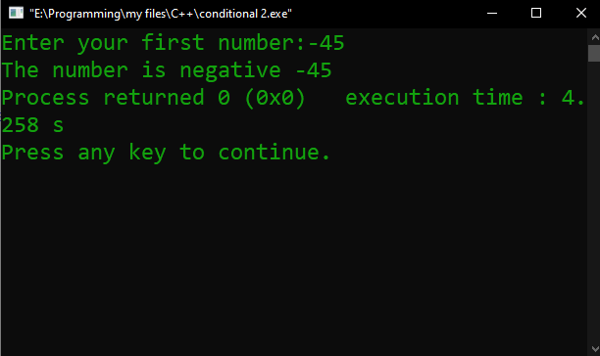
Figure 2 Output

Description:
Begin with // indicating that this one line is a comment, //Find the inputted number is positive or negative”. I insert comments to document programs and improve program readability. My Comments do not cause the computer to perform any action when the program is run. In the 1st line I used a comment for indicate the purpose of this code. In line 2 I used a library function called #include which is a directive to the C preprocessor. In the 4th line the main function begins execute the program. In the main function int main () all the function were written enter in the curly brace {}.
The names x is the names of variables. In this program first of all I used int x; This means that it needs to be worked on those variables. Then I used printf for user prompt, “Enter the first number”. Our next program uses the Standard Library function scanf to obtain two integers typed by a user at the keyboard, computes the compare of these values by using conditional operator and prints the result using printf for showing “The positive or negative number” in the monitor.
The output is also here, as we can see the output in fig 2 In line 9 I indicate that the program ended successfully by using return 0;

Problem No. 03
Name of the problem:
Write a C program to check whether the given number is odd or even using the conditional operator in C
Introduction
Implementing program in C is very interesting. To implement the problem given above we should remember the procedure to display outcome. That is, we should consider about the required inputs, the particular process that will be applied upon the input data and the output whether it is desired or not. The given problem gives me an opportunity to have an exercise on the procedure.

Program:
//check whether the given number is odd or even
#include <stdio.h>

int main()
{
int x;
printf("Enter your first number:");
scanf("%d",&x);

(x%2==0) ? printf("The number is even: %d",x) : printf("The number is odd: %d",x);
return 0;
}

Output:
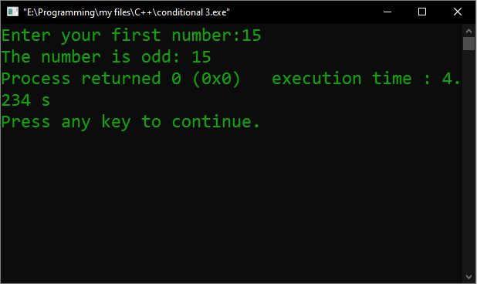
Figure 3 Output

Description:
Begin with // indicating that this one line is a comment, //check whether the given number is odd or even”. I insert comments to document programs and improve program readability. My Comments do not cause the computer to perform any action when the program is run. In the 1st line I used a comment for indicate the purpose of this code. In line 2 I used a library function called #include which is a directive to the C preprocessor. In the 4th line the main function begins execute the program. In the main function int main () all the function were written enter in the curly brace {}.
The names x is the names of variables. In this program first of all I used int x; This means that it needs to be worked on those variables. Then I used printf for user prompt, “Enter the first number”. Our next program uses the Standard Library function scanf to obtain two integers typed by a user at the keyboard, computes the compare of these values by using conditional operator and prints the result using printf for showing “The number is odd or even” in the monitor.
The output is also here, as we can see the output in fig 3. In line 9, I indicate that the program ended successfully by using return 0;
Problem No. 04
Name of the problem:
Write a program to enter two numbers. Make a comparison between them with the conditional operator. If the first number is greater than the second, perform a division operation otherwise multiplication operation.
Introduction
Implementing program in C is very interesting. To implement the problem given above we should remember the procedure to display outcome. That is, we should consider about the required inputs, the particular process that will be applied upon the input data and the output whether it is desired or not. The given problem gives me an opportunity to have an exercise on the procedure.
Program:
/*Making a comparison between 2 numbers with the conditional operator. If the first number is greater than the second, perform a division operation otherwise multiplication operation*/
#include <stdio.h>
int main()
{
int x,y,div,multi;
printf("Enter your first number:");
scanf("%d",&x);
printf("Enter your second number:");
scanf("%d",&y);
(x>y) ? printf("the division of 2 numbers:%d",div=x/y) : printf("the multiplication of 2 numbers:%d",multi=x*y);
return 0;
}

Output:

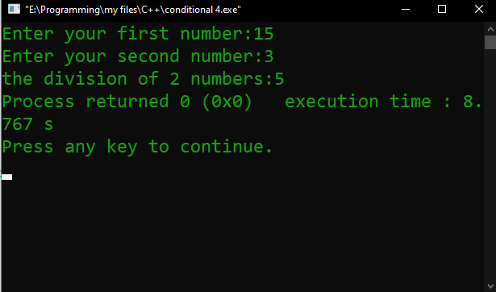
Figure 4 Output
Description:
Begin with // indicating that this one line is a comment, “/*Making a comparison between 2 numbers with the conditional operator. If the first number is greater than the second, perform a division operation otherwise multiplication operation*/”. I insert comments to document programs and improve program readability. My Comments do not cause the computer to perform any action when the program is run. In the 1st line I used a comment for indicate the purpose of this code. In line 2 I used a library function called #include which is a directive to the C preprocessor. In the 4th line the main function begins execute the program. In the main function int main () all the function were written enter in the curly brace {}.
The names x, y, div and multi are the names of variables. In this program first of all I used int x, y, div, multi; This means that it needs to be worked on those variables. Then I used printf for user prompt, “Enter the first number”. Our next program uses the Standard Library function scanf to obtain two integers typed by a user at the keyboard, compares & the calculate of these values by using div=x/y & multi=x*y and prints the result using printf for showing “The Division/ Multiplication of 2 numbers” in the monitor. The output is also here, as we can see the output. I indicate that the program ended successfully by using return 0;

Problem No. 05
Name of the problem
Use the conditional operator to produce a code to have the following sample input and output. Sample Output for the different test-cases:-
Enter the number of items: 1 ---------- You have 1 item.
Enter the number of items: 2 ---------- You have 2 items.
Introduction
Implementing program in C is very interesting. To implement the problem given above we should remember the procedure to display outcome. That is, we should consider about the required inputs, the particular process that will be applied upon the input data and the output whether it is desired or not. The given problem gives me an opportunity to have an exercise on the procedure.

Program:
#include <stdio.h>

int main()
{
int item;
printf("Enter the number of items:");
scanf("%d",&item);

printf("you have %d item%s",item,(item==1) ? "" : "s");
return 0;
}

Output:
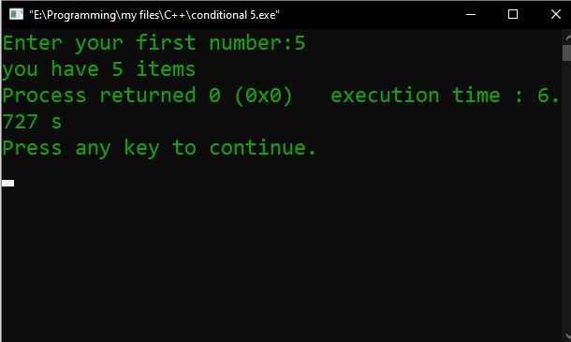
Figure 5 Output
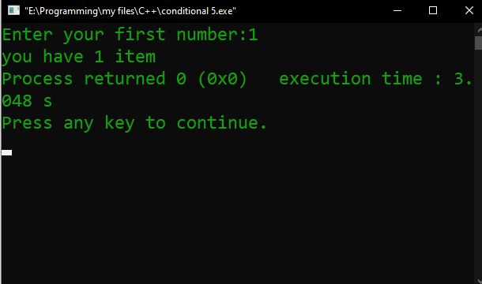
Figure 6 output

Description:
I use the conditional operator to produce a code to have the following sample input and output. Sample Output for the my test-cases:-
Enter the number of items: 5 ---------- You have 5 items.
Enter the number of items: 1 ---------- You have 1 item.
In the 1st line I used a comment for indicate the purpose of this code. In line 2 I used a library function called #include which is a directive to the C preprocessor. In the 4th line the main function begins execute the program. In the main function int main () all the function were written enter in the curly brace {}.
The name item is the names of variables. In this program first of all I used int item; This means that it needs to be worked on those variables. Then I used printf for user prompt, “Enter the number of items”. Our next program uses the Standard Library function scanf to obtain two integers typed by a user at the keyboard, compares & the calculate of these values by using Conditional Operator and prints the result using printf for showing “You have 5 items or You have 1 item” in the monitor. The output is also here, as we can see the output. I indicate that the program ended successfully by using return 0;

Problem No. 06
Find the largest among three numbers using the conditional operator.
Introduction
Implementing program in C is very interesting. To implement the problem given above we should remember the procedure to display outcome. That is, we should consider about the required inputs, the particular process that will be applied upon the input data and the output whether it is desired or not. The given problem gives me an opportunity to have an exercise on the procedure.
Program;
//Find the largest among three numbers using the conditional operator
#include <stdio.h>
int main()
{
int x,y,z;
printf("Enter your 3 numbers:\n");
scanf("%d %d %d",&x,&y,&z);

(x>y) ?
((x>z) ?
printf("The largest number is %d",x):printf("The largest number is %d",z)):
((y>z) ?
printf("The largest number is %d",y):printf("The largest number is %d",z));
return 0;
}

Output:

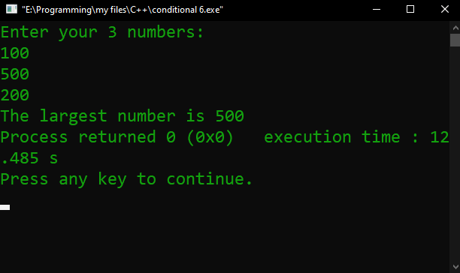
Output 6
Description:
Begin with // indicating that this one line is a comment, “//Find the largest among three numbers using the conditional operator”. I insert comments to document programs and improve program readability. My Comments do not cause the computer to perform any action when the program is run. In the 1st line I used a comment for indicate the purpose of this code. In line 2 I used a library function called #include which is a directive to the C preprocessor. In the 4th line the main function begins execute the program. In the main function int main () all the function were written enter in the curly brace {}.
The names x, y, z are the names of variables. In this program first of all I used int x, y, z; This means that it needs to be worked on those variables. Then I used printf for user prompt, “Enter the 3 numbers”. Our next program uses the Standard Library function scanf to obtain two integers typed by a user at the keyboard, computes the compare of these values by using conditional operator and prints the result using printf for showing “The largest number” in the monitor.
The output is also here, as we can see the output in fig 6 In line 13 I indicate that the program ended successfully by using return 0;

Problem no. 07
Write a C program to input a character and check whether the character is alphabet or not using Conditional operator.
Introduction
Implementing program in C is very interesting. To implement the problem given above we should remember the procedure to display outcome. That is, we should consider about the required inputs, the particular process that will be applied upon the input data and the output whether it is desired or not. The given problem gives me an opportunity to have an exercise on the procedure.
Program:
//character check whether the character is alphabet or not
#include <stdio.h>
int main()
{
char x;
printf("Enter your character:");
scanf("%c",&x);

(x>='a' && x<='z') || (x>='A' && x<='Z') ?
printf("The character is a:%c",x) : printf("The character is not an alphabet:%c",x);
return 0;
}

Output:
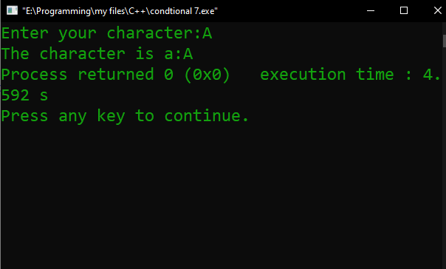
Figure 7

Problem No. 08
Write a C program to check leap year using Conditional operator.
Introduction
Implementing program in C is very interesting. To implement the problem given above we should remember the procedure to display outcome. That is, we should consider about the required inputs, the particular process that will be applied upon the input data and the output whether it is desired or not. The given problem gives me an opportunity to have an exercise on the procedure.
Program:
//check leap year using Conditional operator
#include <stdio.h>
int main()
{ int x;
printf("Enter your year:");
scanf("%d",&x);
(x%4==0 && x%100!=0) || (x%400==0) ? printf("the year %d is leap year",x):printf("the year %d is a common year",x);
return 0; }
Output:
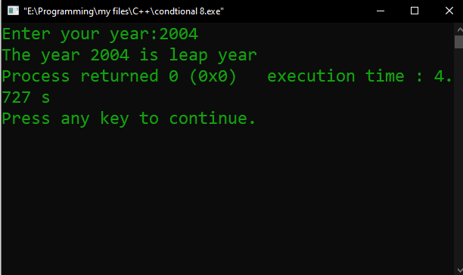
Output of leap year
Problem No. 09
Produce a code yourself to have the clear concept of comma operator, bitwise operator
Introduction
Implementing program in C is very interesting. To implement the problem given above we should remember the procedure to display outcome. That is, we should consider about the required inputs, the particular process that will be applied upon the input data and the output whether it is desired or not. The given problem gives me an opportunity to have an exercise on the procedure.
Program:
#include <stdio.h>

int main()

{

int a,b;

printf("Enter your 2 numbers:\n");

scanf("%d %d",&a,&b);

//a=12,23,34;
//b(12,23,34);

printf("And operation of 2 numbers %d\n",a&b);
printf("OR operation of 2 numbers %d\n",a||b);

return 0;

}

Output:
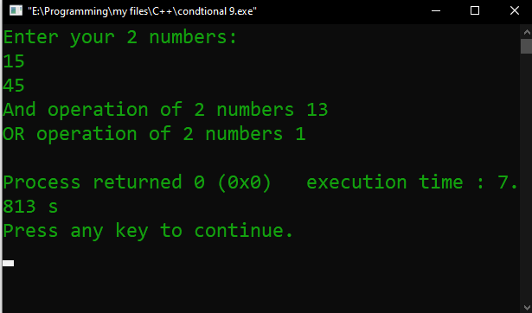
output

THE END

